Home Router

🏠 What is a Home Router?
# Source: Chatgpt (GPT‑5 Mini) at [12/18/2025]
A home router is a device that allows multiple devices in your home (like smartphones, laptops, smart TVs) to connect to the internet and communicate with each other. It combines several network functions into a single box, making it simple for non-technical users to set up a home network.

🔧 Functions of a Home Router
# Source: Chatgpt (GPT‑5 Mini) at [12/18/2025]
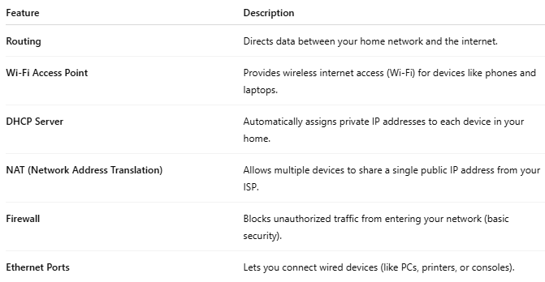
Feature | Description
Routing | Directs data between your home network and the internet.
Wi-Fi Access Point | Provides wireless internet access (Wi-Fi) for devices like phones and laptops.
DHCP Server | Automatically assigns private IP addresses to each device in your home.
NAT (Network Address Translation) | Allows multiple devices to share a single public IP address from your ISP.
Firewall | Blocks unauthorized traffic from entering your network (basic security).
Ethernet Ports | Lets you connect wired devices (like PCs, printers, or consoles).

📦 A Home Router Usually Includes:
# Source: Chatgpt (GPT‑5 Mini) at [12/18/2025]
- ✅ WAN port (to connect to your modem)
- ✅ 4+ LAN ports (for wired devices)
- ✅ Built-in Wi-Fi
- ✅ Power adapter
- ✅ Admin interface (accessed via web browser to manage settings)

🔁 Example: How a Home Router Works
# Source: Chatgpt (GPT‑5 Mini) at [12/18/2025]
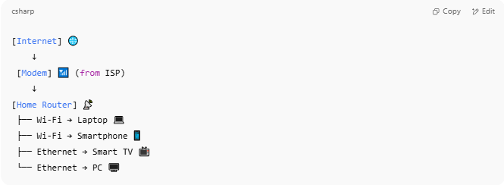
[Internet] 🌐
↓
[Modem] 📶 (from ISP)
↓
[Home Router] 📡
├── Wi-Fi → Laptop 💻
├── Wi-Fi → Smartphone 📱
├── Ethernet → Smart TV 📺
└── Ethernet → PC 🖥️

📌 In Summary:
# Source: Chatgpt (GPT‑5 Mini) at [12/18/2025]
- A home router is your gateway to the internet.
- It acts like a traffic manager, a wireless access point, and a basic security guard.
- It simplifies networking for everyday users.

